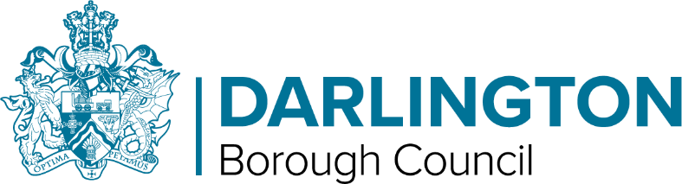 | Office use only  Ref No:  Date Received:  Date Acknowledged:

Darlington Local Plan
Proposed Modifications Consultation

Comments Form

Thank you for your interest in the proposed modifications to the Local Plan and associated documents. Please complete the form in black ink or type. The main method for consultation responses to be submitted is via our online consultation portal http://darlington-consult.objective.co.uk/portal. We would recommend that if you have a lot to say you reply this way. If you need help filling in this form please contact the Planning Policy Team on 01325 406724.

All comments received will be acknowledged and passed on to the Inspector conducting the examination of the Darlington Local Plan. The Modifications are proposed without prejudice to the Inspectors’ final conclusions of the plan, which will take into account all of the representations submitted in response to this consultation.
You can view the Main Modifications, modifications to the Policies Map, Sustainability Appraisal of the modifications and the Habitats Regulations Assessment of the Modifications on the Council's website at https://darlington.objective.co.uk/portal/, or a paper copy of the documents can also be viewed at the Council Customer Contact Centre, or Darlington and Cockerton Libraries, during normal opening hours.

Your Contact Details | Agent Contact Details (if applicable)
Name:  Organisation:  Address:  Postcode:  Telephone:  E-mail: | Name:  Organisation:  Address:  Postcode:  Telephone:  E-mail:
If you have supplied an e-mail address, are you happy for it to be the main way that the Council contacts
you about future consultations on planning policy documents?
Yes No
The contact name and a summary of all the comments made as part of this representation may be made available on the Council's website. In compliance with the General Data Protection Regulations (GDPR) and the Data Protection Act 2018, the personal information you have provided will only be used by the Council for the purposes of preparing the Local Plan and associated documents.

Thank you for your interest in the Local Plan. Please tick the following boxes so we know whether or not you wish to be contacted again about planning in Darlington:

I wish to be notified of the progress of the Local Plan

I wish to be consulted on other planning documents being prepared by the Council

Forms must be completed and returned to the council by 5pm on
Tuesday 30th November 2021.

Your comments on the Proposed Modifications to the Local Plan

Question 1
Which Document/Modification does this representation relate to?
(Please tick one per comment and include modification number where appropriate)

□ Main Modification Schedule Reference number: MM___________
□ Policies Map Modification Schedule Reference number: PM___________
□ Sustainability Appraisal Report Addendum
□ Habitats Regulations Screening Assessment Report Addendum
□ Minor Modifications Schedule Reference number: MIN____________

Question 2
What best describes the nature of your representation?

Support |  | Object
Please tick as appropriate

Question 3
Do you consider the Plan, incorporating the proposed Modification is:

- Legally compliant | Yes |  | No
- Sound | Yes |  | No
Please tick as appropriate

Question 4
Please give details of why you consider the Darlington Local Plan, incorporating the proposed Modifications to which your representation relates, is not legally compliant or is unsound. Please be as precise as possible. If you wish to support the Plan or comment on the Sustainability Appraisal Report Addendum/Habitats Regulations Screening please also use this box to set out your comments.

(Continue on a separate sheet/expand box if necessary)

Question 5
Please set out what changes you consider necessary to make the Plan legally compliant or sound and why, thinking about what you identified in Question 4. It will be helpful if you are able to put forward your suggested revised wording of any policy or text. Please be as precise as possible.

(Continue on a separate sheet/expand box if necessary)

PLEASE NOTE: Comments will be made available online either during or after the consultation has finished.

Please return the completed form by 5pm 30th November 2021 to:

Planning Policy Team  Darlington Borough Council  Town Hall  Darlington, DL1 5QT | Tel: 01325 406724  Email: planning.policy@darlington.gov.uk

